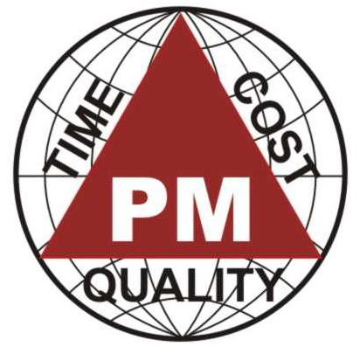
IIPM
Invitation
Professional Development Day & IIPM Alumni DINNER Meet
Sunday, 9 December 2007
Venue: Hotel Quality Inn Sabari, T.Nagar
A. AGENDA FOR PROFESSIONAL DEVELOPMENT DAY:
Brainstorming of PMBOK Guide: PMO in IT Industry: The Relevance & Challenges
Invited Speakers:

09.30 - 09.40 am - Welcome Drink

09.40 – 09.45 am - Welcome Address by Mr. Siva, Admin Exec., IIPM

09.45 – 10.00 am - Inaugural Address by Mr. O. Arivazhagan, PMP, SSBB, CEO, IIPM
Vice Chair: Marketing, DPC-SIG, PMI, USA
Topic - PMO in IT Industry: The Relevance & Challenges
10.00 – 10.30 am – Mr. Abiraman, BE, MBA, PMO Analyst, Polaris Software Lab Ltd,
Topic – PMO: Roles &Responsibilities
10.30 – 11.00 am – Mr. Dipanker Das, M.Tech, PMP, SSGB, Project Manager, CGN IT,
Topic – PMO: Implementation Experiences- A Case study
Special Invitee :
11.00 – 11.10 am – Mr. Tony Jacob, B.Tech, PMP, PGD (CM), Operational Consultant,
Aconex India, Chair –Professional Development, DPC-SIG, USA
Topic – PMO in Construction through Online Collaboration- A Case study
11.10 – 11.30 am –Mr M. Sakthi Vel –Dy.Manager – State Bank of India
Topic – PMO: Which Organizational Structure is best suited?

11.30 – 12.00 am - Refreshments Break

12.00 – 12.30 pm – Mr. Lakshmi Narayanan, MBA, PMP ,Associate Manager-Delivery, Vittusa India,
Topic – PMO: Roles &Responsibilities
12.30 – 01.00 pm – Mr. Raj Kadirvelu, MCA, PMP, Program Manager, Satyam Computers
Topic - PMO Implementation Experiences -A Case study
01.00 – 01.30 pm – Mr.Dhanesh Kunar, MBA,PMP,Project Manager,WIPRO
Topic – PMO: Which Organizational Structure is best suited?

01.30 – 02.30 pm - Lunch Break

02.30 – 03.00 pm – Mr. Ramakrishnan, Former GM, CGL
Topic – PMO: Implementation experiences: A case study

Professional Development Day & IIPM Alumni DINNER Meet
Sunday, 9 December 2007
03.00 – 05.00 pm -PANEL DISCUSSION

Topic: PMO in IT Industry: The Relevance & Challenges”

- Panelist 1: Mr. Ravichandran, MBA, CEO, Indus CyberTech

- Panelist 2: Ms. Gayathri Balaswamy, MBA, PMP, Vice-President, M&A Integration, ISG Nova Soft

- Panelist 3: Mr. Jawahar Venkatraman, Project Manager, PMP

- Panelist 4: Mr. Ajit Kumar , MCA,MS,PMP, Delivery Manager, Logica CMG

- Panelist 5: Mr. Ashok Sharma , ICWA,ACS,PMP, SAP Project Manager, SEAL InfoTech

- Panelist 6: Ms. V.S.Srividhya, MCA, PMP, Senior Project Manager, Infosys Technologies Limited.

Panel Moderator: Mr. O.Arivazhagan, B.E (Honors), PMP, SSBB, CEO, IIPM

05.00 – 05.30 pm – Memento / Award / 7 PDU Certificates Distribution

05.30 - 05.40 pm – Vote of Thanks –Mr. Allabaksh, PMP, Project Manager, IIPM InfoTech

B. IIPM ALUMNI DINNER:

6.00 – 7.00 pm – Cocktail Networking Reception

6.05 – 7.00 pm – Movie Trailer – “The Perfect Knot”
(A digital film project managed by IIPM using PMBOK Methodology)

07.00 – 08.00 pm– Dinner
RSVP:
Shiva : + 91 9884433487
Kalaivani : + 91 44 42071124 / 24359078 / 42641401

E-mail: marketing@iipmchennai.com
All Are Cordially Invited
O.Arivazhagan (Ari), PMP, SSBB
CEO, IIPM.

